REAL-TIME SIGN LANGUAGE
INTERPRETATION SYSTEM

Avantika Mishra
Regd. No. 181209115
8th semester, CSE
avantikamishra31.am@
gmail.com
Isha Bharadwaj
Regd. No. 1801209192
8th semester, CSE
ishabharadwaj08@gmail.com

Annada Gumansingh
Regd. No. 181209076
8th semester, CSE
annada.gumansingh@gmail.com
Anmol Ray
Regd. No. 1801209073
8th semester, CSE
anmolray04@gmail.com

Supervised by Dr. Soumya Priyadarsini Panda

Abstract — Conversing to a person with hearing disability is always a major challenge. Deaf and Mute people use sign language to communicate, hence normal people face problems in recognizing their language by signs made. Generally sign language consists of hand gestures and facial expressions. In this, hand gestures were considered to recognize the letters and words. We have used different deep learning models to predict the sign.
Keywords — sign language, movement recognition, deep learning, models, communication

Introduction
Communication is very crucial to human beings, as it enables us to express ourselves. We communicate through speech, gestures, body language, reading, writing or through visual aids, speech being one of the most commonly used among them. However, unfortunately, for the speaking and hearing impaired minority, there is a communication gap. Visual aids or an interpreter are used for communication. However, these methods are rather cumbersome and expensive, and can't be used in an emergency. Sign Language mainly uses manual communication to convey meaning. This involves simultaneously combining hand shapes, orientations, gestures and movement of the hands, arms or body to express the speaker's thoughts.
Sign Language consists of finger spelling, which spells out words character by character, and word level association which involves hand gestures that convey the word meaning. Finger spelling is a vital tool in sign language, as it enables the communication of names, addresses and other words that do not carry a meaning in word level association. In spite of this, finger spelling is not widely used as it is challenging to understand and difficult to use. Moreover, there is no universal sign language and very few people know it, which makes it an inadequate alternative for communication.
A system for sign language recognition that classifies hand gestures and finger spelling can solve this problem. Various techniques are used and their accuracies are recorded and compared in this report.

Ease of Use

Purpose of the model
Sign languages are defined as an organized collection of hand gestures having specific meanings which are employed from the hearing impaired people to communicate in everyday life. Being visual languages, they use the movements of hands, face, and body as communication mediums. There are over 300 different sign languages available all around the world. Though there are so many different sign languages, the percentage of population knowing any of them is low which makes it difficult for the specially-abled people to communicate freely with everyone. SLR is a way to communicate in sign language without prior knowledge of it. It recognizes a gesture and translates it into a commonly spoken language like English.

Maintaining the Integrity of the Model
SLR is a very vast topic for research where a lot of work has been done but still a lot of things need to be addressed. Different models have given high accuracy results, but the accuracy does not depend only on the processing model used, it depends upon various factors such as size of the dataset, clarity of images of the dataset depending upon data acquisition methods, devices used, etc. In this paper, it has been done by TensorFlow object detection API. The system has been trained on the American Sign Language alphabet dataset. The system detects sign language in real-time. For data acquisition, images have been captured by a webcam using Python and OpenCV which makes the cost cheaper. Though the system has achieved a high average confidence rate, the dataset it has been trained on is small in size and limited.

PREPARING THE MODEL
Collect Images with the help of OpenCV to leverage webcam to collect images for training. After that setup labelImg, which is an open source package that allows to label images for object detection and label each one of the sign language poses. Update Lablemap and train the model after setting up the configuration. This will load the model and regenerate it based on the training which will lead to detect sign language in real time.

Abbreviations and Acronyms
Abbreviation Description
API Application Programming Interface
ASL American Sign Language
BSL British Sign Language
HCI Human Computer Interface
ISL Indian Sign Language
OpenCV Open Source Computer Vision Library
SLR Sign Language Recognition

Equations
.
In the Tensorflow Object Detection API, there are majorly three commonly used optimizers :
- Momentum Optimizer
- RMS_Prop Optimizer
- Adam Optimizer

-Momentum Optimizer
This is the optimizer that SSD MobileNet uses. The idea behind Momentum is that the information given by the gradient for a single step is not enough, and that some second order approach (like Newton’s Method) could help us get out of convergence traps.
What it actually does is that it accumulates the gradient of the previous steps to determine which direction to search for our minima. Here are the new equations :
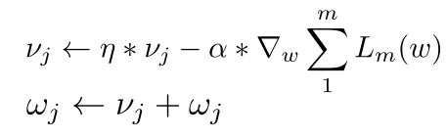
The first equations where the gradient calculation takes place is composed of two parts, the first one is the accumulation of the gradient over steps, with η the value of the momentum, and the second one is our main gradient term.
This means that over time, we are taking an exponential average of the gradient steps, the most recent term is weighted with η, the second with η squared, the third with η cubed etc… (as shown in the following equations with a momentum value of 0.9)
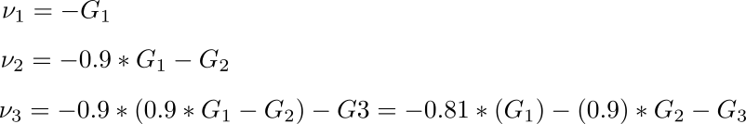
As we can see, the importance of each gradient step in the computation of the actual step is decreasing over time.

Some Common Mistakes
In the starting of the model, trying to clone the repository in Google Colab and attempting to set up the entire environment in local machine might not work. In order to make it work upload the repository in drive and mount the drive to Colab. Set up labelImg.
Error might occur while capturing the video because cv2.VideoCapture() is not opening the web camera when executing the command in Google Colab because the code runs on the “cloud” (i.e. on a remote server). The processing happens on google’s servers, they’ll have no physical access to your device. So when you trying to have VideoCapture read the first local (local to where the code runs) camera won’t work. Using Javascript resolves the problem and helps in capturing video from webcam on the local device. We have used SSD architecture and did NOT use yolo.

Using the Template
Our proposed system is recognising sign language using Tensorflow Object Detection API by performing transfer learning using SSD MobileNet. It recognizes seven hand gestures by capturing photos from real time using a webcam. Then the hand pixels are segmented and the image it obtained and sent for comparison to the trained model. Thus our system is more robust in getting exact text labels of letters using LabelImg for labeling.
The exact pre trained model we are using for transfer learning is SSD MobileNet v2 fpnlite 320X320 coco17 tpu-8 model.

The domain analysis that we have done for the project mainly involves the following

TensorFlow
TensorFlow is a free and open-source software library for dataflow and differentiable programming across a range of tasks. It is a symbolic math library, and is also used for machine learning applications such as neural networks. It is used for both research and production at Google.

Features: TensorFlow provides stable Python (for version 3.7 across all platforms) and C APIs; and without API backwards compatibility guarantee: C++, Go, Java, JavaScript and Swift (early release). Third-party packages are available for C#, Haskell Julia, MATLAB,R, Scala, Rust, OCaml, and Crystal."New language support should be built on top of the C API. However, not all functionality is available in C yet." Some more functionality is provided by the Python API.

Application: Among the applications for which TensorFlow is the foundation, are automated image-captioning software, such as DeepDream.

OpenCV
. OpenCV (Open Source Computer Vision Library) is a library of programming functions mainly aimed at real-time computer vision. Originally developed by Intel, it was later supported by Willow Garage then Itseez. The library is cross-platform and free for use under the open-source license.

LabelImg
LabelImg is a graphical image annotation tool. It is written in Python and uses Qt for its graphical interface. Annotations are saved as XML files in PASCAL VOC format, the format used by ImageNet.

Figures
Here, SSD (Single Shot Detector) is reviewed. By using SSD, we only need to take one single shot to detect multiple objects within the image, while regional proposal network (RPN) based approaches such as R-CNN series that need two shots, one for generating region proposals, one for detecting the object of each proposal. Thus, SSD is much faster compared with two-shot RPN-based approaches.
SSD is a single-shot detector. It has no delegated region proposal network and predicts the boundary boxes and the classes directly from feature maps in one single pass.
To improve accuracy, SSD introduces:
- small convolutional filters to predict object classes and offsets to default boundary boxes.
- separate filters for default boxes to handle the difference in aspect ratios.
- multi-scale feature maps for object detection.
SSD can be trained end-to-end for better accuracy. SSD makes more predictions and has better coverage on location, scale, and aspect ratios. With the improvements above, SSD can lower the input image resolution to 300 × 300 with a comparative accuracy performance. By removing the delegated region proposal and using lower resolution images, the model can run at real-time speed and still beats the accuracy of the state-of-the-art Faster R-CNN.
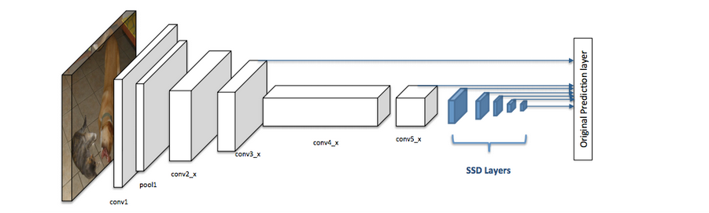

Digital-Image :

An image may be defined as a two-dimensional function f(x, y), where x and y are spatial(plane) coordinates, and the amplitude of fat any pair of coordinates (x, y) is called the intensity or grey level of the image at that point.

In another word An image is nothing more than a two-dimensional matrix (3-D in case of coloured images) which is defined by the mathematical function f(x, y) at any point is giving the pixel value at that point of an image, the pixel value describes how bright that pixel is, and what colour it should be.

Image processing is basically signal processing in which input is an image and output is image or characteristics according to requirement associated with that image.

Image processing basically includes the following three steps :

- Importing the image
- Analysing and manipulating the image
- Output in which result can be altered image or report that is based on image analysis
The following image shows the result of the used mode:
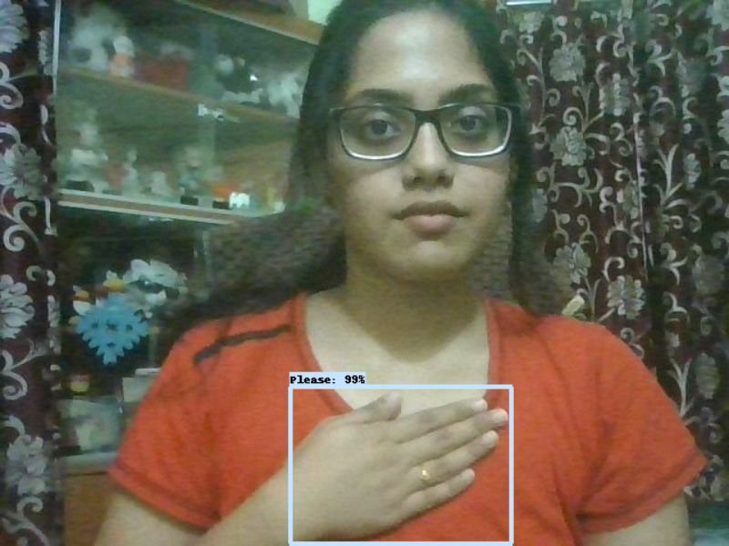

Conclusions
Sign languages are kinds of visual languages that employ movements of hands, body, and facial expression as a means of communication. Sign languages are important for specially-abled people to have a means of communication. Through it, they can communicate and express and share their feelings with others. The drawback is that not everyone possesses the knowledge of sign languages which limits communication. This limitation can be overcome by the use of automated Sign Language Recognition systems which will be able to easily translate the sign language gestures into commonly spoken language. In this paper, it has been done by TensorFlow object detection API. The system has been trained on the American Sign Language alphabet dataset. The system detects sign language in real-time. For data acquisition, images have been captured by a webcam using Python and OpenCV which makes the cost cheaper. Though the system has achieved a high average confidence rate, the dataset it has been trained on is small in size and limited.

In the future, the dataset can be enlarged so that the system can recognize more gestures. The TensorFlow model that has been used can be interchanged with another model as well. The system can be implemented for different sign languages by changing the dataset.

Acknowledgment
We would like to express our deep gratitude to our project guide Dr. Soumya Priyadarsini Panda, Senior Assistant Professor, Department of Computer Science & Engineering, for her guidance with immense knowledge and encouragement.

References
- Daiyi Peng, Xuanyi Dong, Esteban Real, Mingxing Tan, Yifeng Lu Hanxiao Liu, Gabriel Bender, Adam Kraft, Chen Liang, Quoc V. Le, "PyGlove: Symbolic programming for automated machine learning", Advances in Neural Information Processing Systems, Vol. 33, pp. 96-108, 2020.
- Zhang Shujun and Qun Zhang, "Sign language recognition based on global-local attention", Journal of Visual Communication and Image Representation, Vol. 80, Article id: 103280, 2021.
- I. A. Adeyanju, O. O. Bello, and M. A. Adegboye, "Machine learning methods for sign language recognition: A critical review and analysis", Intelligent Systems with Applications, Vol. 12, Article id: 200056, 2021.
- Brandon Garcia, Sigberto Alarcon Viesca, “Real-time American Sign Language Recognition with Convolutional Neural Networks”, Stanford University Stanford, CA, 2016
- Sawant Pramada, Deshpande Saylee, Nale Pranita, Nerkar Samiksha, Mrs.Archana S. Vaidya, “Intelligent Sign Language Recognition Using Image Processing”, IOSR Journal of Engineering (IOSRJEN), Volume 3, Issue 2, PP 45-51, 2013
- Pratibha Pandey , Vinay Jain, “An Efficient Algorithm for Sign Language Recognition”, (IJCSIT) International Journal of Computer Science and Information Technologies, Vol. 6, 2015
- Anup Kumar, Karun Thankachan, Mevin, M. Dominic, “Sign Language Recognition”, IEEE-India, 2016
- Ashish S. Nikam, Aarti G. Ambekar, “Sign language recognition using image based hand gesture recognition techniques”, IEEE-India, 2016
- Nicholas Renotte, ‘RealTimeObjectDetection’, 2020 [Online]. Available: https://github.com/nicknochnack [Accessed: 27-Feb-2022]
- Vaishshells. ‘Sign Language Recognition for Computer Vision Enthusiasts’, 2021 [Online]. Available: https://www.analyticsvidhya.com/blog/2021/06/sign-language-recognition-for-computer-vision-enthusiasts/ [Accessed: 17-Jan-2022]
- João Carreira, Andrew Zisserman, “Quo Vadis, Action Recognition? A New Model and the Kinetics Dataset”, IEEE-USA, 2017
- Ching-Hua Chuan, Eric Regina, Caroline Guardino, “American Sign Language Recognition Using Leap Motion Sensor”, IEEE-USA, 2014
- Data Flair, ‘Sign Language Recognition Using Python and OpenCV’, 2022 [Online]. Available: https://data-flair.training/blogs/sign-language-recognition-python-ml-opencv/ [Accessed: 12-Jan-2022]
- Yuancheng Ye, Yingli Tian, Matt Huenerfauth, and Jingya Liu, “Recognizing American Sign Language Gestures from within Continuous Videos”, The Graduate, The City College, Rochester Institute of Technology, Rochester, New York, USA, 2018

